Task 10
Practice task
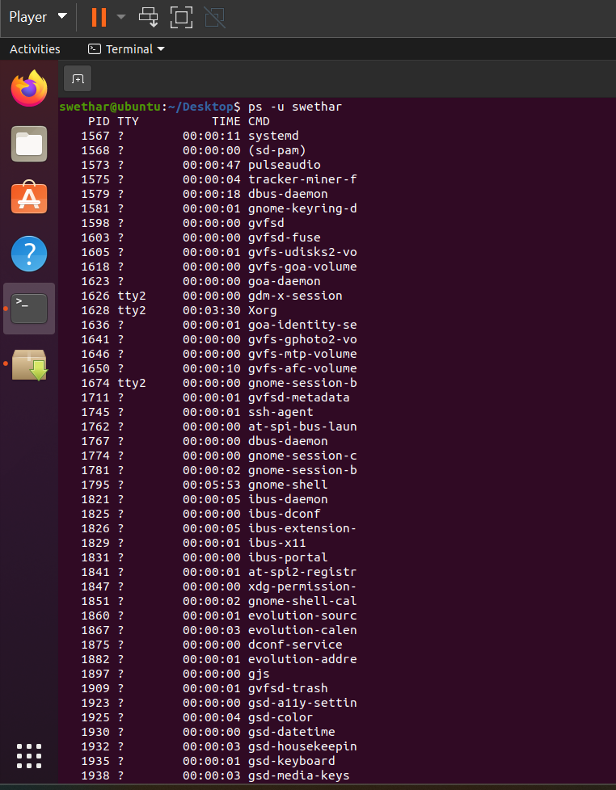
Additional task
1. What is the diff between http and https
HTTP | HTTPS
HyperText Transfer Protocol | HyperText Transfer Protocol Secure
Data is not encrypted | Data is encrypted using SSL/TLS
Less secure | More secure
Port 80 | Port 443

2. How can you view all processes for a specific user
ps -u username
3. What is the diff between hostname -I and hostname -i
Command | Purpose
hostname -I | Shows all IP addresses of the system
hostname -i | Shows IP address resolved from hostname

